IPOPT: The Interior Point OPTimizer of Astrogator
Ethan Whitaker, Analytical Graphics, Inc.

Abstract
IPOPT, the Interior Point Optimizer, is an optimization tool recently implemented in Astrogator, inside STK. The algorithm finds a locally optimal solution based on a user defined problem, and its primary role is to compute the most efficient of a spacecraft’s possible maneuvers. An incredibly powerful problem solver, IPOPT is capable of handling nearly infinite combinations of variables. In this paper, two practical scenarios using IPOPT are examined, including an optimized low-thrust transfer to geostationary orbit. Finally, best practices are presented to encourage successful use of the tool.

Introduction to IPOPT
Space flight depends heavily on optimization. A feasible mission often requires minimizing time, propellant mass, or both. Tens of thousands of dollars can be saved by reducing fuel onboard the spacecraft by just a few kilograms. Thus, finding an optimal trajectory through space is paramount. Astrogator has already established itself as the tool to plan spacecraft maneuvers, and now IPOPT provides the capability to maximize efficiency. IPOPT is an optimization profile within Astrogator that was introduced with STK 11.3 in order to meet the needs of space mission planners.

Interior Point Method
IPOPT is a large optimization software package that falls under the category of non-linear programming (NLP) solvers. It is well-known and used in industry, and it is an open source product. The Interior Point Optimizer’s algorithm is used to solve nonlinear systems of equalities and inequalities, while maximizing or minimizing an objective (cost) function.³ The problems it can solve are general and take the following form:

$$\min{f\left(x\right) x∈R^{n}}$$
$$s.t. g^{L}≤g\left(x\right)≤g^{U}$$
$$x^{L}≤x≤x^{U}$$

The variable x represents the control variables that vary within the given bounds. The function f(x) is the cost function to be minimized, and g(x) represents the constraint functions, which can be bounded or given one value. Such a constraint is called an equality constraint.⁶

The solver’s name refers to the logarithmic barrier function that forces the program to search points only in an interior, feasible space. This barrier function essentially converts an inequality to an equality that the computer can solve.¹ The algorithm then computes the Hessian matrix, which contains 2nd derivatives and mixed derivatives of a function. The Hessian is used to determine the search direction to find local minima, which is the goal of optimization. Then, a backtracking line search, using a filter method, computes the appropriate step size to take towards a solution.⁹ Each iteration of IPOPT involves solving large indefinite linear systems, so Astrogator uses a linear solver software package called MUMPS to do some of the heavy lifting.³

The IPOPT algorithm searches for a locally optimal solution. That is, the program will output the best solution in the vicinity of the initial guess, but not necessarily the best global solution.

Implementation in Astrogator
With the goal of consistency in mind, IPOPT was implemented in the same format as other targeting profiles. These are used within the Target Sequence, a type of segment in Astrogator’s Mission Control Sequence. Perhaps the most familiar targeting profile is the Differential Corrector, commonly used to target different aspects of a satellite’s orbit by varying certain control parameters. The optimizing profiles work in very much the same way. Control variables are activated from the segments nested in the target sequence, and results (constraints) are selected from these segments as well; the difference is that a third element is added to the customizable profile menu: the objective function. This value (or values) is (are) selected to be minimized or maximized, and therefore the mission sequence is optimized.

 | Decision Variables | Constraints | Objective Functions
Description | Allowed to vary (controls) | Define the set of acceptable solutions | Quantity to minimize or maximize
Examples | Finite burn duration, Coast time | Eccentricity, Inclination | Delta-v, Duration
Figure 1. The three parameters of an IPOPT profile are defined.

When an IPOPT profile is activated in the target sequence, an output display window appears, showing the user how the variables are changing as the algorithm iterates toward the optimal solution. The objective function is displayed at the top of this window, and the program ends when this value is at its minimum while all constraints are met within their bounds and tolerances.

Two Use Cases
The two cases featured in this white paper were chosen to showcase the capabilities of IPOPT, applied to current problems. The first case is a satellite de-orbit maneuver, and the second is an optimized mission to geostationary earth orbit (GEO) using a low-thrust engine. These scenarios should not be taken as wholly realistic nor ideal, but as examples of how one might use IPOPT to optimize spacecraft maneuvers.

Controlled Deorbit Mission
Some satellite operators may prefer to intentionally remove a satellite from orbit at or near the end of its lifetime. This is often the case for a large satellite that would not be completely destroyed by aerodynamic forces in the atmosphere.⁵ This scenario makes use of the IPOPT profile to determine the minimum delta-v that might be required to crash a LEO satellite into the ocean. Knowing the minimum amount of fuel to reserve for a de-orbit burn would be useful for mission planners.
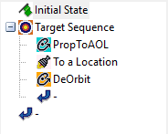
Thrust | 500 N
Dry Mass | 500 kg
Periapsis Altitude | 150 km
Eccentricity | 0.01
Inclination | 28.5 deg
RAAN | 0 deg
Arg. of Periapsis | 0 deg
True Anomaly | 0 deg

Figures 2-3. Initial state and satellite parameters; mission control sequence for the DeOrbit satellite.

To set up this scenario, the satellite named DeOrbit was initialized in Astrogator in a low altitude, inclined, near-circular orbit. Then, the target sequence was created, composed of a propagate segment, followed by a maneuver and a final propagate segment. The first propagate segment ends when the satellite reaches a variable argument of latitude. The maneuver segment is modeled as impulsive, and performs a variable thrust in the velocity direction. The final propagate segment ends when the satellite’s altitude falls below 5 m.

A differential corrector profile and an IPOPT profile in succession were used to determine the optimal location and delta-v of the maneuver to minimize the delta-v, while reaching a specified longitude, 150 ̊ W, at the impact point. The controls were the argument of latitude of the first propagate segment’s stopping condition and the delta-v of the impulsive maneuver. The constraints were the longitude and altitude at the end of the sequence, and the initial objective function was the same delta-v of the maneuver.

This scenario offers a good example of the IPOPT profile significantly improving upon a differential corrector profile, as each run of the IPOPT profile lowered the delta-v by at least 1-2 m/s from the differential corrector’s results.

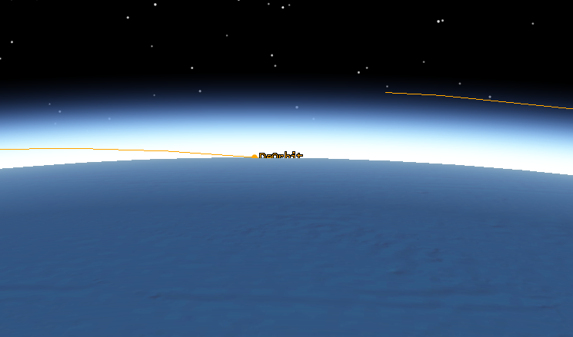
Figure 4. The DeOrbit satellite reaches sea level at about 150 ̊ W and 26 ̊ N.

Some valuable lessons were learned while designing this scenario. First of all, argument of latitude was chosen over true anomaly due to the circularity of the orbit—true anomaly is better defined for more eccentric orbits—and this led the optimizer to converge. Also, the first initial guess converged to a solution of about 65 m/s. A subsequent guess converged to a better value of 58 m/s. These converged rapidly due to very high tolerance values. When the convergence tolerance was lowered from 0.1 to 0.001, the same initial guess converged to a value of 54 m/s. Thus, a higher convergence tolerance promotes rapid computation time, but does reduce the optimality of the solution.

The Point-Mass propagator used initially was replaced by the HPOP propagator, which incorporates drag into the solution. The IPOPT profile struggled to converge with this additional complexity, but massaging the initial guess and bounding the control variables (delta-v: between -5 and -100 m/s) led to convergence at the lower bound of 5 m/s. After multiple passes, the drag force was enough to bring the satellite down on its own, as expected.

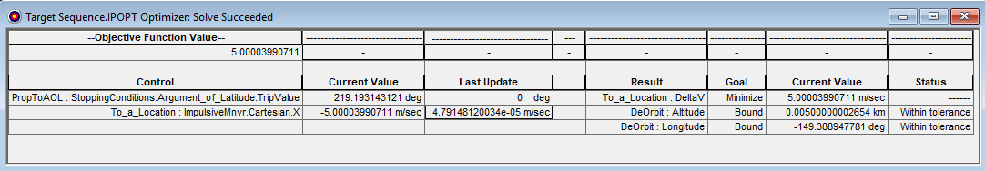
Figure 5. Successful convergence of the IPOPT profile using the HPOP propagator.

The next experiment performed was to minimize time to deorbit alongside the delta-v. Having two objective variables in the IPOPT profile results in an objective function that is the summation of the two, which the algorithm then attempts to minimize. This change decreased the de-orbit time from 226 minutes to 191 minutes, but increased the delta-v to 18.4 m/s.

A further adjustment to the profile was weighting the objective variables. The objective variables are multiplied by their weight value before being added together. By giving the deorbit duration a weighted value of 2 (the default is 1), the deorbit time dropped to 17 minutes, while requiring a delta-v of 100 m/s, the given upper bound. From this experiment, we see that IPOPT can be advantageous for identifying tradeoffs by weighting objectives differently.

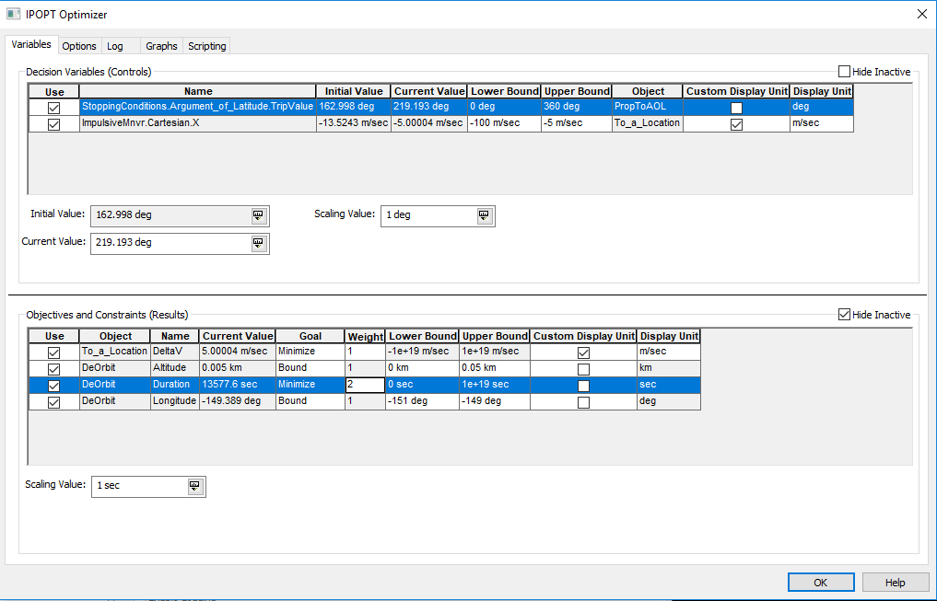
Figure 6. IPOPT profile with two objective functions. Note the weight values for DeltaV and Duration.

Low Thrust GEO Mission
This scenario involves raising the periapsis of a satellite in a geosynchronous transfer orbit (GTO) to reach a geostationary orbit (GEO). To make this example applicable to current topics, and to feature some of the powerful components of Astrogator, this mission was accomplished using a low-thrust electric engine. The engine’s properties were based on the X3 Hall thruster that is being developed by a team at the University of Michigan.⁷

Thrust | Specific Impulse (I_{sp}) | Dry Mass | Initial Fuel Mass
5 N | 2000 s | 1000 kg | 1000 kg
Table 1. Engine and spacecraft parameters.

As electric propulsion systems provide very low thrust, maneuvers that require large delta-v have much higher durations—on the order of weeks and months. Due to the hazards of high levels of radiation in low altitudes, this mission begins in a GTO rather than a low earth orbit (LEO) to avoid spending large amounts of time in low altitudes.^{2,8} There are multiple approaches that could be taken to attempt to optimize the trajectory of the satellite to GEO. In this case, IPOPT was used to minimize the delta-v of each successive burn as the satellite raised its periapsis.

 | Altitude of Apoapsis | Altitude of Periapsis | Inclination
Initial State (GTO) | 35,793 km | 185 km | 0 deg
Final State (GEO) | ~36,000 km | 35,793 km | 0 deg
Table 2. Initial and final states of the satellite.

The mission control sequence is deceptively simple: the GTO orbit is initialized, and then a propagate sequence is run. However, the propagate sequence contains an auto-sequence that is iterated until the periapsis radius reaches GEO altitude (using the constraint feature). Using the auto-sequence function allows each orbit pass to be optimized, rather than trying to optimize the entire mission all at once; there are simply too many finite burns in this case to optimize them all in one target sequence. The auto-sequence involves a target sequence containing a propagate segment and a maneuver segment. Inside this target sequence, the spacecraft coasts to some optimal true anomaly, where it then performs an optimized finite burn that raises its periapsis by 200 km, relative to the previous segment. To find these optimal values, a differential corrector profile is run first to locate a solution space; then, the IPOPT profile is run to identify the best feasible values. Additionally, the change in altitude of apoapsis is minimized to help the optimizer choose the correct solution.

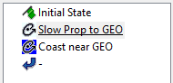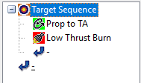
Figure 7. Left, the principal MCS; right, the auto-sequence MCS.

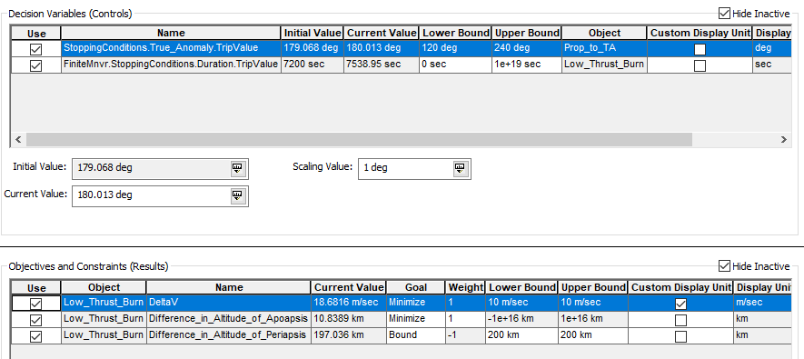
Figure 8. Variables tab of the IPOPT window for the low-thrust GEO mission.

The results of this mission control sequence were somewhat unexpected. The mission required a delta-v total of 1601.4 m/s, spread out over 178 maneuvers. The time from beginning to end was about 4 months. The most important figure is the amount of fuel used: 149.1 kg. The benefits of electric propulsion are obvious when this figure is compared to a typical chemical apogee engine that would burn in the region of 400 kg of fuel in a similar mission. However, due to the simplified nature of the mission, the IPOPT profile may not provide the most optimal results in this case. A similar, albeit more constrained method using only the differential corrector resulted in a lower delta-v of 1488 m/s. The IPOPT profile, in some runs, selected a true anomaly far from apogee, which was likely not optimal; this is evidence of the algorithm finding a locally optimal solution that is not globally optimal. Still, some future fine-tuning of the sequencing may allow a user of IPOPT to achieve equal or better results than the differential corrector. This scenario could be built upon in the future to include a plane change along with the orbit circularization; optimized incremental burns that could accomplish this would surely improve upon existing methods. Also, other schemes of achieving GEO altitude may be more efficient than the one studied here.

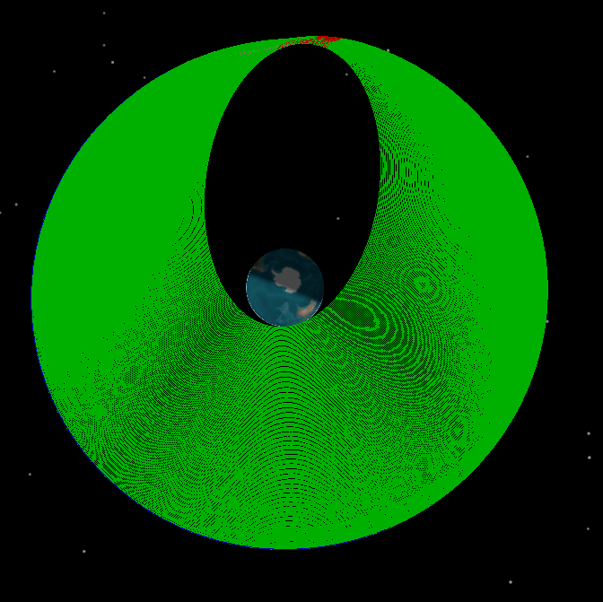
Figure 9. GTO to GEO circularization. Finite burns are colored red, coasting is green.
Discussion—Best Practices
The optimizing profiles in Astrogator provide a function that was previously underdeveloped. It does not replace the differential corrector, which will continue to be the principal tool used for finding solutions and reaching target values. However, IPOPT is able to build upon the differential corrector and fine tune maneuvers in order to plan the best missions. IPOPT has been found to be most successful when implemented in simple problems, typically involving 2-4 control variables. However, it is capable of handling problems of larger scale, provided it is set up correctly.

As is evident, IPOPT is a complex problem solving tool. There are infinite ways to customize an IPOPT profile, but not all of these will result in a converging and optimal solution. An IPOPT user must also take into consideration the computation time of his or her problem. Thus, there are a few practices that will help to successfully find an optimal solution without sacrificing unreasonable amounts of time.

Setting up the Problem
Much of IPOPT’s success will be determined by the problem created by the user. There are an endless number of combinations of controls, constraints, and objectives, and Astrogator is not currently capable of communicating to the user what combinations will lead to a feasible solution before IPOPT is run. Thus, a user should understand the functions involved in the problem; some functions are smoother than others and will better facilitate the derivative calculator. A lot of knowledge of the differential corrector will carry over into the optimizer. For example, true anomaly should not be used on a highly circular orbit; argument of latitude is much smoother. Also, rather than targeting eccentricity and inclination, especially near zero, users should target flight path angle and velocity azimuth.

Also, the problem can be characterized by the number of each type of variable. Obviously, there should be at least 1 objective variable. Another common problem is having too many constraints. A good rule of thumb is to have an equal or greater number of controls than constraints, and to avoid having more constraints than controls; there needs to be at least one free variable to be able to optimize. Users also have the option to bound the controls and constraints, and this gives IPOPT more room to find an optimal solution. With only equality constraints, IPOPT seems to perform at the level of the differential corrector. (An equality constraint has equal lower and upper bounds.) If control variables and constraints are properly bounded based on the user’s knowledge, IPOPT will have a much easier time of locating a feasible solution space.

Initial Guesses
This practice cannot be stressed enough. The IPOPT algorithm must identify a feasible solution space before it can optimize anything. If it starts its search already inside or near a feasible solution, then chances for a successful run are significantly higher. Thus, it is important to initialize the control variables close to the expected solution. This can be made easier by beginning the target sequence with a differential corrector, followed by the IPOPT profile. A differential corrector profile can iterate to find feasible solutions much faster than the IPOPT profile, but will not optimize. As the number of control variables and objective functions increases, it becomes more important to provide “close” initial guesses. To come up with these “close” values, one might first use analytical equations from orbital mechanics, or run a simpler but similar problem in Astrogator.

Tolerances
One exposed option that greatly affects the IPOPT profile is the convergence tolerance. This can be edited in the Options tab inside the IPOPT GUI. The convergence tolerance is what determines the success or failure of the algorithm. IPOPT takes the actual value of the constraint function and divides it by the desired value; if this normalized constraint value is within the tolerance, then the solution converges. The default convergence tolerance is 1e-8, which often makes the computation time quite lengthy. Increasing this tolerance by magnitudes is often required to converge to a solution quickly. However, this obviously will reduce the accuracy of the solution. The other tolerances are the constraint violation tolerance, dual infeasibility tolerance, and the complementary infeasibility tolerance; these all must be met before the convergence tolerance is checked. Increasing these lesser tolerances will also increase the algorithm’s speed, but the convergence tolerance has the greatest effect.

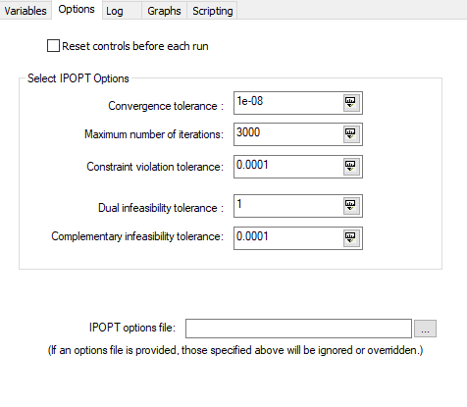
Figure 10. The Options tab of the IPOPT Optimizer window.

If a given constraint should be a fixed value, it is best to keep it as an equality constraint rather than expanding the bounds by a small amount. To give the solution some flexibility, the convergence tolerance can be adjusted instead. This will save computation time.

Other IPOPT Tips
The following tips are a few pieces of handy knowledge gained over the course of this research project:
- If an IPOPT profile fails to converge over and over, it is possible that the control variables need to be reset. Pressing the reset button in the target sequence can be easy to forget, but using it avoids a lot of frustration. An alternative is to make use of the “Reset controls before each run” option that will do this automatically.
- Seeing the numbers move does not mean it is iterating; it is calculating derivatives from the perturbations. Changing the maximum number of iterations may be useful to end the program early if it is stuck in a non-feasible space.
- IPOPT can be customized with an options file. These have a file type of ‘.opt’, and are simple two-line text files. This file can set the values of tolerances, change the number of maximum iterations, and revise the output of the log. The log output can help users identify why an IPOPT run did not converge. Many of the algorithm’s settings can be accessed only by an options file. Documentation of these options can be found online at the IPOPT home page.⁴ Below is an example of an options file that would reduce the amount of information presented in the log and adjust some of the options:

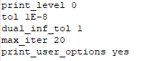
Figure 11. Sample IPOPT options file.

Common Errors
The following errors are the most frequent when an IPOPT solution does not converge. Some suggestions are given to help users understand why they occur and how to overcome them.
- Restoration Failed. The purpose of the restoration phase is to reduce the infeasibility value of the problem, and the algorithm enters this phase when the optimization process is “stuck.” This error is generated when the program cannot successfully exit the restoration phase, because it cannot find a satisfactory point for the filter line search. It’s possible that this error occurs in a solvable problem, but more than likely, the problem is too difficult, and the user should try to redefine the problem with smoother functions, or try a new initial guess.⁴
- Infeasible Problem Detected. This error typically means that the problem is not solvable. Either the functions are not smooth or the given constraints and control bounds do not allow for a solution. This can also occur when the initial guesses are too far from a feasible solution. To address this error, a user should try a new initial guess.⁴
- Not enough degrees of freedom. While it is tempting to reduce the number of parameters to increase convergence speed, an IPOPT profile must be set up with the appropriate number of control variables. An over-constrained scenario cannot be optimized. A good rule of thumb is to have an equal ratio of decision variables to constraints.⁴

When should I use IPOPT?
An IPOPT profile could be used in any mission with a target sequence. However, it is best used when the given target sequence has a range of possible solutions. It should be used late in the mission planning phase, after the targets have been well defined; fine-tuning the optimizing profile can take a significant amount of time. Lastly, IPOPT is best-suited for problems with few variables. It is capable of handling more, but requires accurate initial guesses and well defined functions.

Some common scenarios that IPOPT might be applied to are 1) determining the location to begin a finite burn with minimal delta-v, 2) selecting the thrust vector to also minimize delta-v, and 3) determining the launch date (epoch) that results in the cheapest deep space mission to the Moon, Mars, etc.

Conclusion
The Interior Point Optimizer is a powerful but complicated tool. Its power comes from the ability to interface with Astrogator and construct an optimization problem with any inputs and any results. When used properly, it can be very successful at improving mission efficiency. This efficiency translates to large monetary savings when spacecraft are deployed with optimized maneuvers. However, the tradeoff is the time spent to set up the problem and compute the solution. Troubleshooting is not trivial, but this paper highlights some of the most common errors and offers suggestions for successful navigation of the tool.

In this paper, IPOPT has been applied to geostationary satellite insertion and controlled de-orbit maneuvers, but the applications are endless. It has been shown that IPOPT generally provides better solutions than existing targeting methods, such as the differential corrector. The implementation in Astrogator has been examined as well; IPOPT has been shown to allow a wide range of customization, providing users with a great deal of control over the solver. In all, the optimizer is a highly useful and greatly needed addition to the Astrogator software package.

Future Research
This examination of IPOPT has exposed many potential areas of further investigation into the optimizer and its capabilities. First of all, it would be worthwhile to compare IPOPT to SNOPT, the other optimization profile implemented in Astrogator. It is likely that one should be chosen over the other, depending on the problem. Second, users might find that a way to automate the use of this tool could be very practical. Research into scripting with IPOPT may help users use it more consistently; along with scripting, the log and the graph features could be taken advantage of more fully. A third research subject could be studying how different propagators affect the optimizer’s output. This would be interesting to study for both near-Earth and interplanetary missions. A final research topic to expand on greatly is convergence: what are the chief sources of errors, how tolerances and bounds impact convergence, and how to determine if a solution is truly the best solution.

References

1. [APMonitor.com]. (2016, March 14). Interior Point Method for Optimization [Video File]. Retrieved from https://www.youtube.com/watch?v=zm4mfr-QT1E

2. Dankanich, J. W., & Woodcock, G. R. (2007). Electric Propulsion Performance from Geo-transfer to Geosynchronous Orbits. Florence, Italy: 30th International Electric Propulsion Conference. doi:IEPC-2007-287

3. Interior Point Optimizer (IPOPT) Profile (Help Page). Retrieved July 19, 2018, from http://help.agi.com/stk/index.htm#gator/ab-IPOPTprofile.htm

4. IPOPT Home Page. (n.d.). Retrieved July 19, 2018, from https://projects.coin-or.org/Ipopt

5. Janovsky, R., Kassebom, M., Lubberstedt, H., & Romberg, O. (n.d.). End-of-life De-orbiting Strategies for Satellites [Digital image]. Retrieved from https://www.dlr.de/Portaldata/55/Resources/dokumente/sart/dglr-2002-028.pdf

6. Kawajir, Y., & Laird, C. (2015, April 16). Introduction to IPOPT: A tutorial for downloading, installing, and using IPOPT [PDF].

7. Manual, B. (2017, October 12). Ion Thruster Prototype. Retrieved July 19, 2018, from https://www.space.com/38444-mars-thruster-design-breaks-records.html

8. Space Radiation Environmental Effects. (2007, February 13). Retrieved from http://holbert.faculty.asu.edu/eee560/spacerad.html

9. Wachter, A. (2002, January 29). An Interior Point Algorithm for Large-Scale Nonlinear Optimization with Applications in Process Engineering (Doctoral dissertation, Carnegie Mellon University, 2002) [Abstract].

