Computing Earthshine intensity for a lunar satellite using STK
Sarthak Srivastava, 08-Apr-2021
Introduction
Earthshine refers to sunlight reflected from Earth onto another object. In this case, we are interested in computing the Earthshine on a spacecraft orbiting the moon. Figure 1 shows the geometry for this problem.

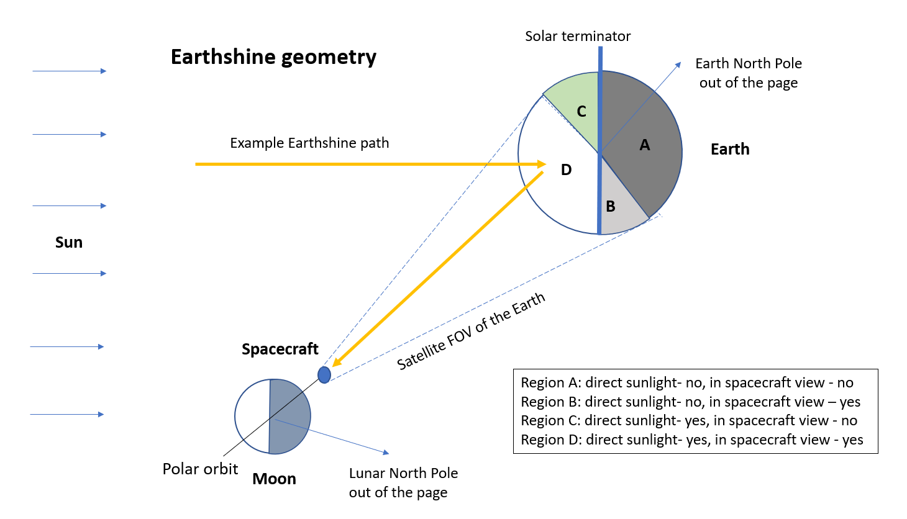
Figure 1. Geometry for calculation of Earthshine on a lunar satellite.
We can divide the Earth into 4 regions, as illustrated in figure 1. It is clear that only region D can contribute towards Earthshine on the spacecraft, since only region D is both visible to the spacecraft AND receiving sunlight (that can be reflected). It is apparent that computation of Earthshine requires knowing the access of spacecraft to the Earth and lighting conditions, among other things.

A model for calculating Earthshine intensity
We can develop a simple analytical model to perform some computations. We can divide the Earth into a latitude-longitude grid and consider a particular grid cell, as shown in figure 2.
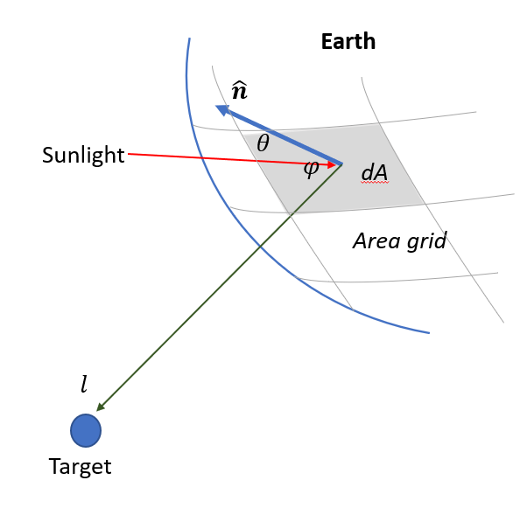
Figure 2. Geometry for a grid cell (shaded gray) on Earth
Sunlight is incident on the grid cell (with area $dA$) at an angle $θ$ with respect to the grid cell normal vector ($\hat{n}$). The reflected light leaves the cell at an angle $φ$ with respect to the normal and reaches the target at distance $l.$
Total Earthshine intensity at any time can be written as
E (W/m²) = $\sum{\frac{(S\cos{θ)}×(acos{φ)}×dA}{l^{2}}}$
where the sum is across all “valid” grid cells on the Earth surface — grid cells having visibility to the target AND receiving sunlight. Incident solar radiance $S$ is ~1367 W/m² at Earth, and $a$ refers to Earth’s albedo. You can perform this computation using STK coverage and some external scripting. This simple model makes the following assumptions:
- Solar irradiance $S$ = 1367 W/m² and is constant.
- The model only considers visible light, not spectral information.
- Albedo= 0.3 and is constant everywhere on the Earth.
- The model assumes a point target and ignores the geometry at target (incidence angle and area).

STK implementation
Required software: STK Systems bundle (Coverage and Integration if using MATLAB)
The main steps involved in creating the scenario are:
- Model the lunar satellite.
- Specify a coverage grid on Earth.
- Create a dummy place object to constraint the coverage. Enable Direct Sun lighting condition on the place object.
- Constrain the coverage to use an instance of the dummy place object. This applies the place’s constraint, which is Direct Sun lighting, to the entire coverage grid.
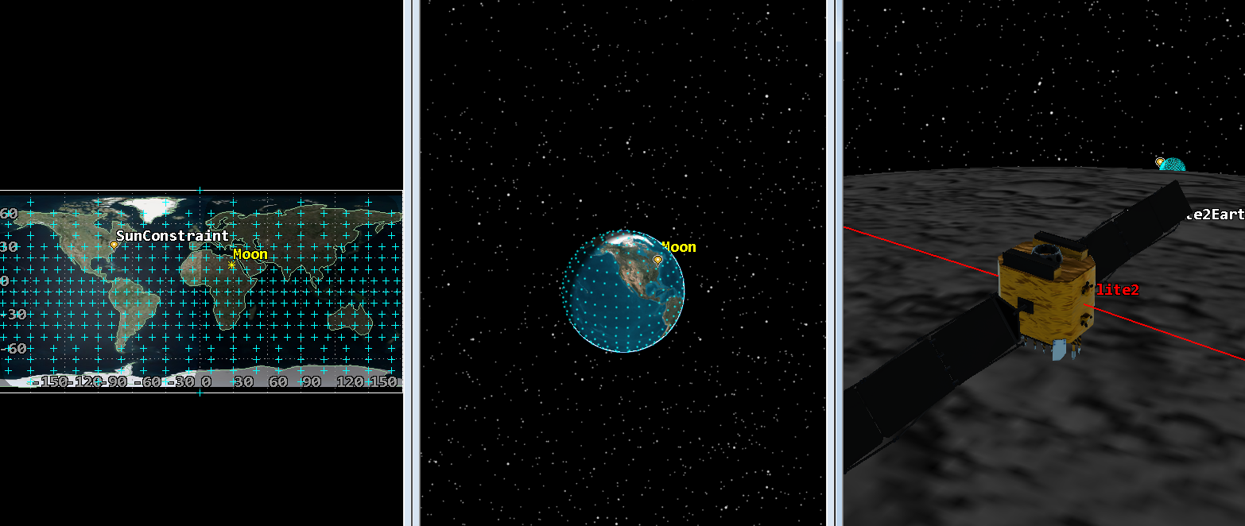
Figure 3. A snapshot from the STK window showing the coverage grid on Earth and the lunar satellite.
- You need the following values across the coverage grid to perform Earthshine computations:
  - Angle between grid cell normal and sunlight vector, also called the Solar Zenith Angle (SZA)
  - Angle between the line of sight from grid cell center to the satellite vector and zenith; also known as the Reflection angle
  - Distance, or range, between the grid cell center and satellite
  - Area of each grid cell
You can use grid properties to easily determine the area of each grid cell. The other three parameters require that you set up a custom calculation. You can do this by creating custom vector geometry and using it to define scalar calculations in Analysis Workbench (AWB). Next you define different Figures of Merit (FOMs) for all three on the coverage grid and set their types to Scalar calculation. Then you attach the calculations created in AWB to the FOMs for computation across the grid.
- Run a MATLAB script to attach to the scenario, extract the required parameters, and perform Earthshine computations.

Results & Discussion
Effect of varying Earth grid resolution
The scenario duration is set to 1 day, and the calculated Earthshine is plotted against time as shown in figure 4. You can specify the Earthshine calculation timestep within a MATLAB script; it is set to 10 minutes in this example. Two cases were run with coverage grid resolutions of 10 degrees and 5 degrees respectively, to observe the effect of a finer grid resolution. We observe that the finer grid (figure 5) results in a more accurate, smoother trend. Specifying even smaller grid resolutions for higher accuracy require a lot of time for computation but offer only a little change in Earthshine values.
Times when Earthshine drops to zero refer to instances when there is no line of sight between the spacecraft and Earth, a result of blocking by the lunar horizon. The long period trend observed in non-zero Earthshine values is because of the variation of sunlight and target phase angles.
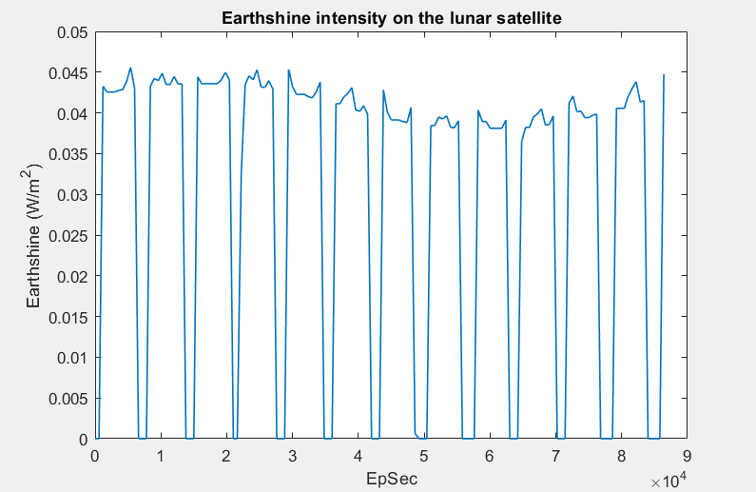
Figure 4. Results for 10-deg resolution grid, 10-minute calculation timestep
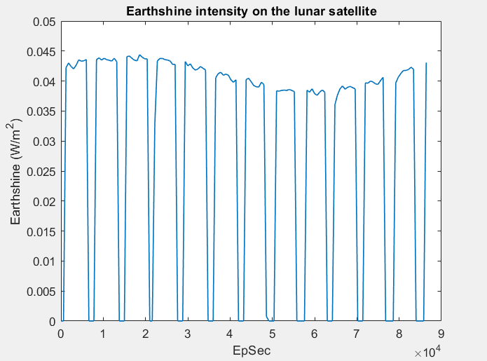
Figure 5. Results for 5-deg resolution grid, 10-minute calculation timestep

Effect of varying orbital parameters
This Earthshine problem is highly geometry dependent. To emphasize this further, we explored another case with a higher lunar orbit of 300 km. Previous results in figures 4 and 5 employ a 100 km circular lunar orbit. Figure 6 shows computed Earthshine at a coarse 10-deg grid resolution obtained by changing the orbit altitude to 300 km. You can see that the spacecraft has prolonged visibility to Earth, owing to a higher orbit altitude. Likewise, variation of other orbital parameters is also expected to result in different computed Earthshine values.

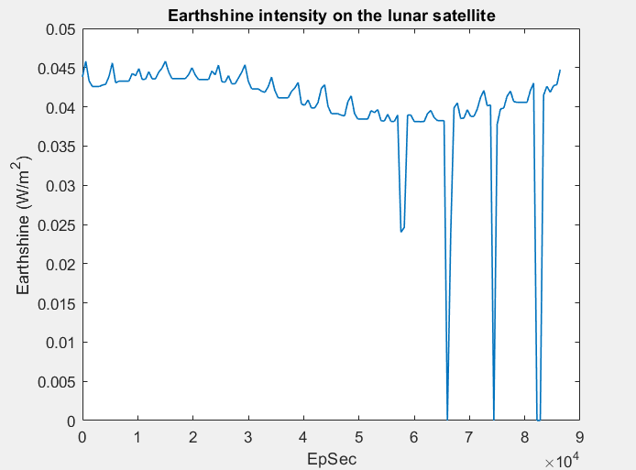
Figure 6. Computed Earthshine for a 300 km circular lunar orbit, showing an example of varying orbital parameters on computed Earthshine with Grid resolution of 10 deg and timestep of 10 mins

Effect of varying analysis time (lunar phase)
Recognizing that different analysis times — differing lunar phases — will also affect the problem geometry, we show an example calculation for four quarters of a lunar cycle. Figure 7 shows computed Earthshine for New Moon (13-14 Mar), First quarter (21-22 Mar), Full Moon (28-29 Mar) and Third quarter (4-5 Apr). The calculations correspond to a 100 km circular lunar orbit. There are drastic differences in Earthshine values.
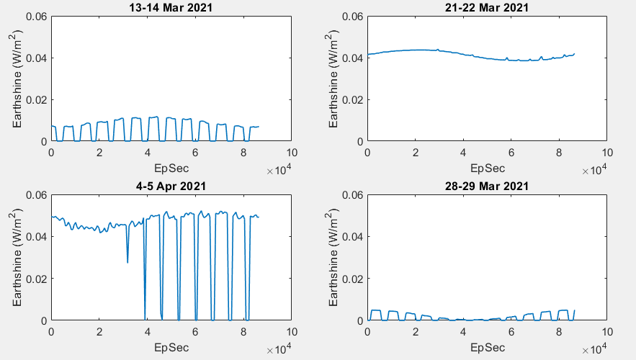
Figure 7. Earthshine computed for four different quarters of the lunar cycle to show dependence of phase on computed Earthshine with a Lunar orbit of 100 km circular, a Grid resolution of 10 deg, and a timestep of 10 mins
.
Comparison with literature
As a sanity check, we refer to a paper by Glenar et al. (2018) to compare our calculations with those in published literature. Using comprehensive 3D modeling, Glenar et al. (2018) found that broadband hemispherical irradiance at the Moon from Earth at full phase is about 0.15 W/m² with comparable contributions from solar reflectance and thermal emission. Very crudely, contribution from solar reflectance alone is approximately 0.07 W/m² at full phase. This provides the upper limit of Earthshine intensity to expect on the lunar surface. In our example, Earthshine irradiance received by the lunar satellite was approximately 0.045 W/m². These values correspond to well below hemispherical coverage, and thus are validated.

