Spectral Flux Density Coverage
To create a scenario that shows Spectral Flux Density, follow these steps:
- Create a satellite object with a transmitter and a facility object with a receiver.
- Make sure the transmitter is set to Data Rate = 2 kbps. This will ensure a 4 kHz Bandwidth using BPSK modulation.
- Create an access between the transmitter and receiver.
- Open the Analysis Workbench.
- Select the Calculation tab and then the Access object.
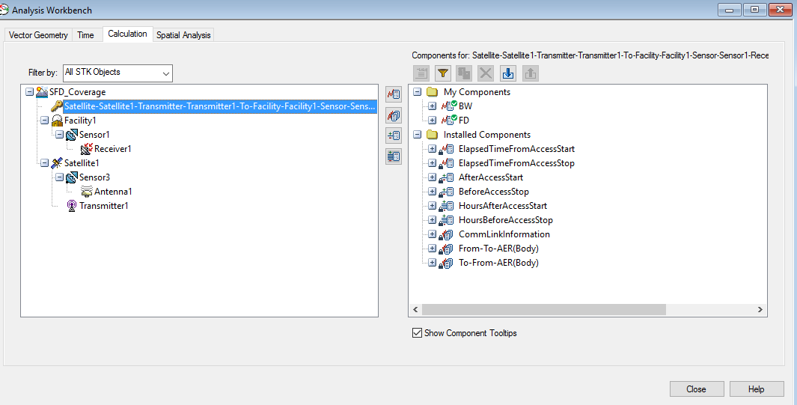

- Create a Scalar Calculation of Data Element type called FD (Flux Density).

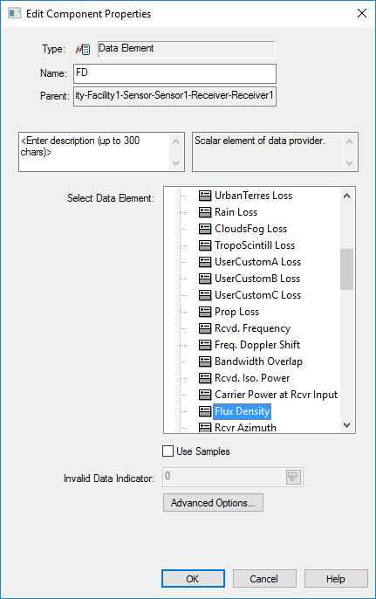

- Select Flux Density and clear the Use Samples checkbox.
- Click OK.

- Create a Scalar Calculation of Data Element type called BW (BandWidth).

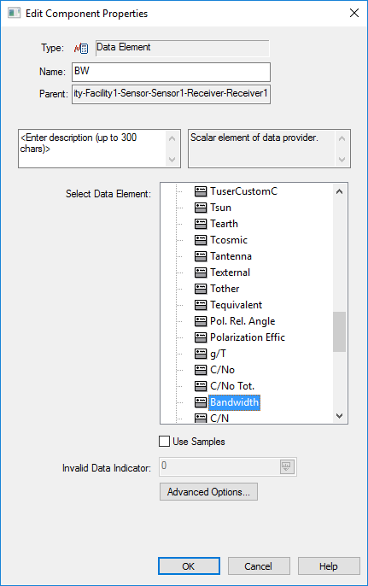

- Select Bandwidth and clear the Use Samples checkbox.
- Click OK.

- Select the Receiver on the left.
- Create a Scalar Calculation of Function(x,y) type called SFD (Spectral Flux Density).

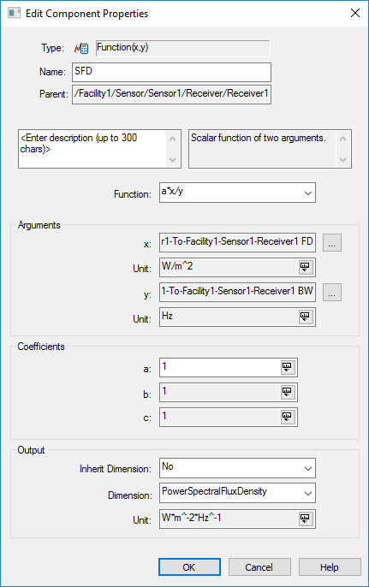

- Make sure the Function = a*x/y (division function).
- Set x = FD, y = BW, and a = 1.
- Set Inherit Dimension = No and Dimension = PowerSpectralFluxDensity.
- Click OK.
- Create a Coverage Definition.
- Set the Asset to be the Transmitter.

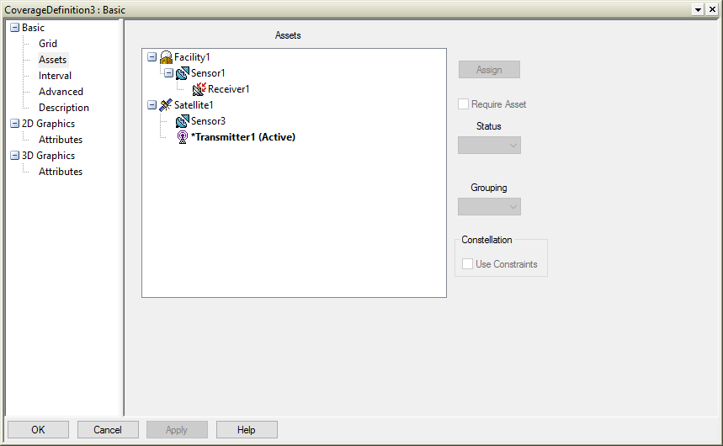

- Set the Grid to be the region of interest and the Point Granularity to be the appropriate value.
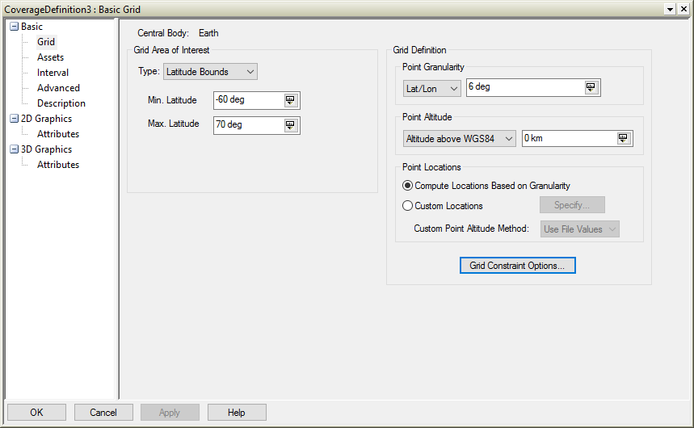

- Set the Grid Constraint Object to be the Receiver and select Use Actual Object on the Grid Points.

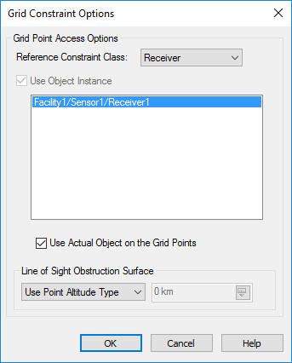

- Create a Figure of Merit as a child object of the Coverage Definition.
- Set the Figure of Merit to be of type Scalar Calculation.
- Set the Scalar Calculation to be SFD.
- Check Update Accesses computed outside of Coverage.

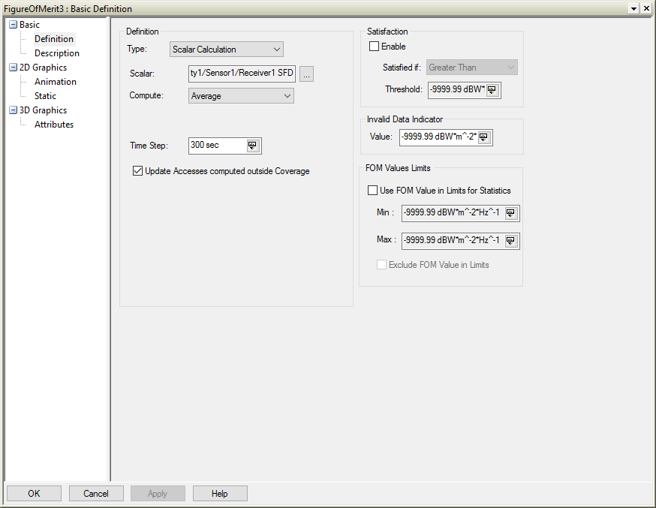
- For the Figure of Merit, select the Report and Graph Manager and run the Grid Stats report.

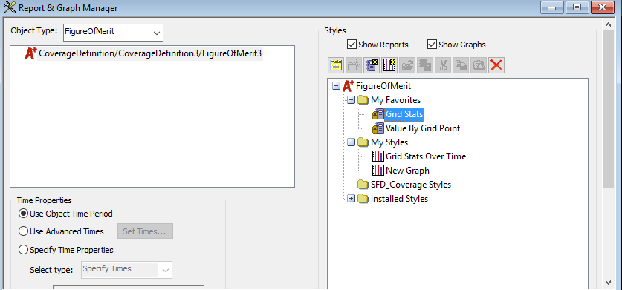

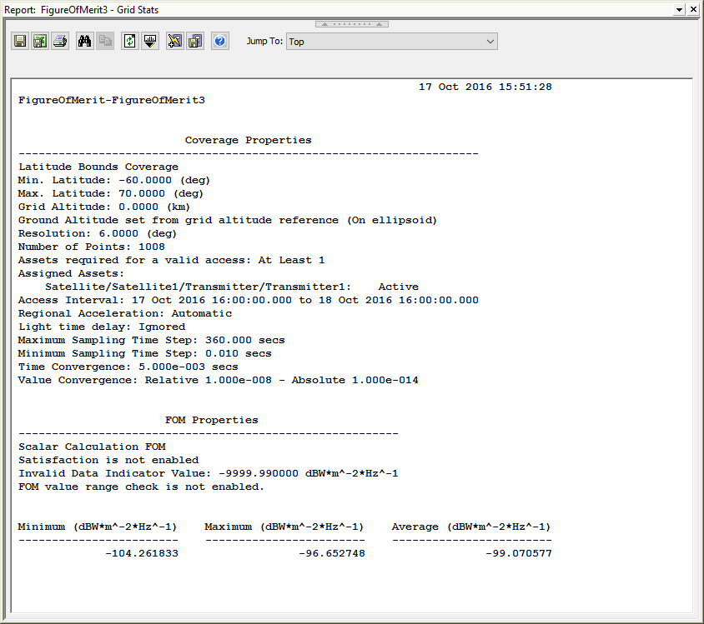
- Set the appropriate graphics levels and Legend for the Figure of Merit.

