Restrict yaw, pitch, and roll angles for an attitude target pointing satellite

- Add various target objects
- Add satellite object using ‘Insert Default’ method
  - Basic > Orbit
    - Name: Sat_YPR_Unrestricted
    - Semimajor axis: 7000 km
    - Eccentricity: 0
    - Inclination: 40 deg
    - AoP: 0 deg
    - RAAN: 0 deg
    - True anomaly: 0 deg
  - Basic > Attitude
    - Check ‘Override Basic attitude for target pointing’
    - Select Targets and move all target objects to Assigned targets
    - Target Times > Use Access Times
- Right-click satellite and open Analysis Workbench
  - Go to Calculation tab
  - Create new ‘Scalar Calculation’
    - Type: Data Element
    - Name: Yaw_ICRF
    - Attitude YPR > Seq YPR > Yaw
    - Click OK
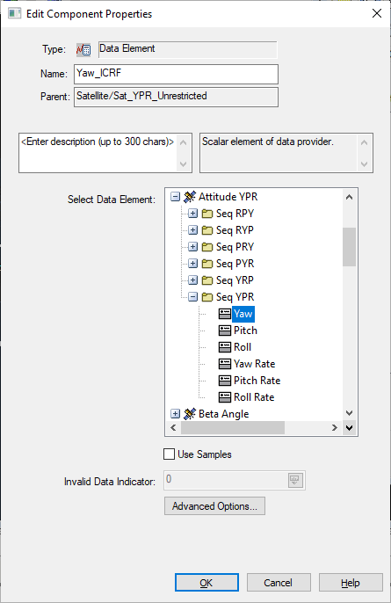
  - Repeat step 3b for ‘Pitch’ and ‘Roll’
  - Create new ‘Condition’
    - Type: Scalar Bounds
    - Name: Yaw_ICRF_Condition
    - Scalar: Sat_YPR_Unrestricted Yaw_ICRF
    - Operation: Between Minimum and Maximum
    - Minimum: -90 deg
    - Maximum: 90 deg
      - Note: these values can be whatever restrictions your satellite has
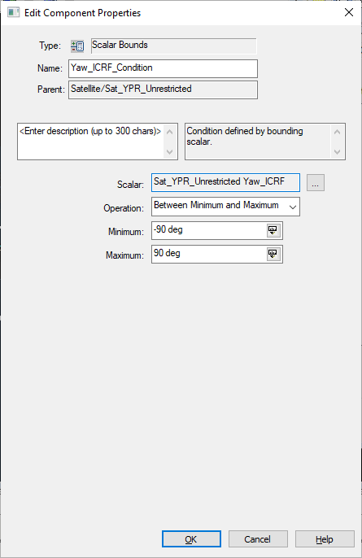
  - Repeat step 3d for ‘Pitch’ and ‘Roll’
    - Make sure you select the correct corresponding ‘Scalar’
- You can right-click any of the scalars and choose ‘Report/Graph’ to generate a report or graph of the angle and the angle rate over the entire scenario period.
- You can right-click any of the conditions and choose ‘Report/Graph’ to generate a report or graph of the condition. This will show 1.0 if the condition is met (satellite’s YPR angles remain within the defined threshold) or -1.0 if the condition is not met.
- In Analysis Workbench, go to the Time tab
  - Create new ‘Interval List’
    - Type: Merged
    - Name: YPR_Angles_Satisfied
    - Operation: AND
    - Remove all intervals
    - Click Add
    - Select Sat_YPR_Unrestricted on the left and select all three yaw, pitch, and roll conditions
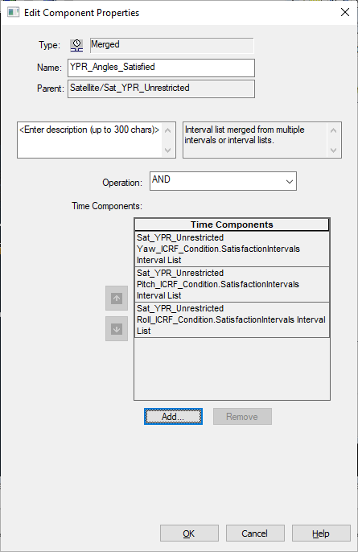
    - This creates an interval list where all three YPR angle restriction conditions are satisfied (satellite’s YPR angles remain within the defined threshold)
- You can right-click the interval list and choose ‘Report’ to generate a report of the intervals
- Create a sensor using the ‘Insert Default’ method and attach it to the satellite
  - Basic > Definition
    - Sensor Type: Rectangular
    - Vertical Half Angle: 0.5 deg
    - Horizontal Half Angle: 0.5 deg
      - This is simply to visualize where the satellite is pointing
- Copy and paste ‘Sat_YPR_Unrestricted’
  - Rename to ‘Sat_YPR_Restricted’
  - Constraints > Temporal
    - Check ‘Use’ under ‘Intervals’
      - Source: Enter intervals
      - Click Import
      - Select Sat_YPR_Unrestricted on the left and choose YPR_Angles_Satisfied on the right
      - You will now see the interval list populated
  - Click Apply
- Now the satellite is only able to point during the time intervals when the YPR angles meet the condition (when all conditions are 1.0)
- You can check this by going to Basic > Attitude > Select Targets > Target Times
  - You’ll notice there are less access times now
- The data displays in the 3D graphics windows are defined the in the satellite properties > 3D Graphics > Data Display
- Additionally, there is a constellation that contains all the target objects and chains that show simultaneous access from the unrestricted and restricted satellites to each of the targets. These time intervals can be seen in the Timeline View at the bottom of the GUI. For more information on Chains and Constellations, please see the help here.

