The Link Margin threshold is specified in the receiver properties as a constant value.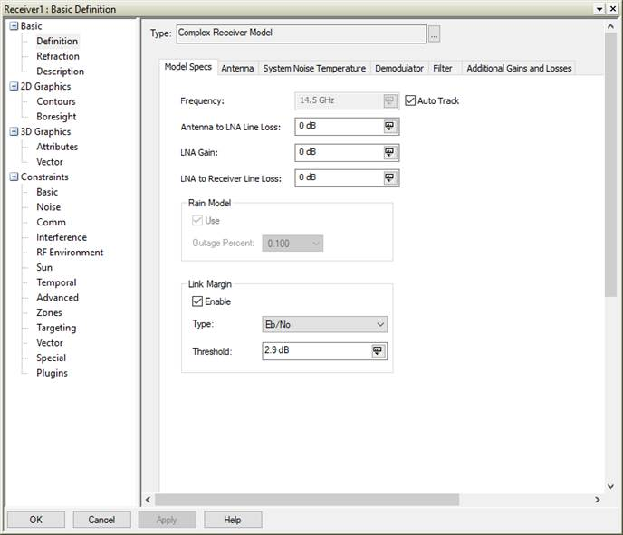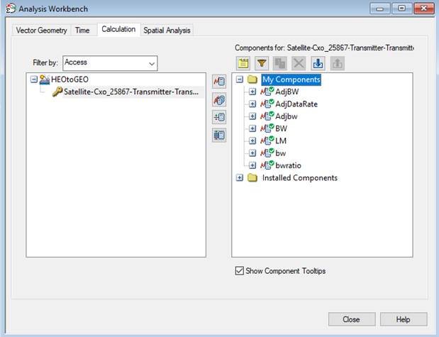

As part of the Link Information Data Provider, you can add Link Margin and Link Margin Value to the Link Budget report.

Link Margin Value is a constant = 2.9 dB based on user setting.

Link Margin (dB) = Eb/No (dB) - Link Margin Value (dB).
Using Analysis Workbench, the following scalar calculations are created:

- Bandwidth – a Data Element taken from the Link Information Data Provider

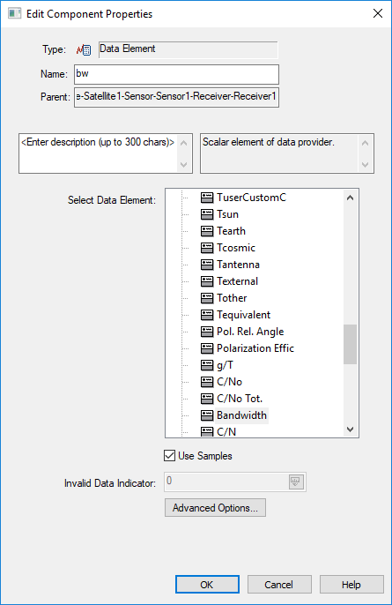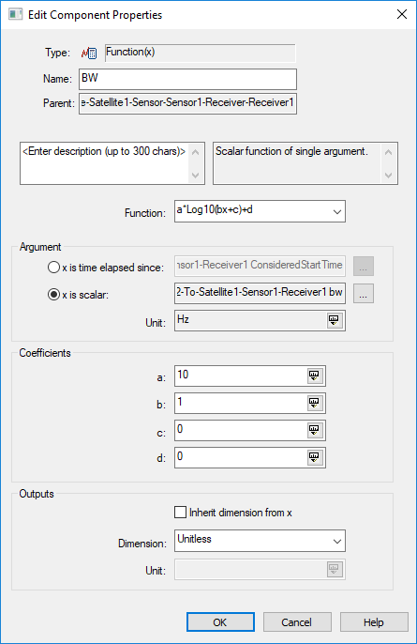

- Bandwidth – result of a function that converts the receiver bandwidth to dB-Hz.
- Link Margin - a Data Element taken from the Link Information Data Provider.
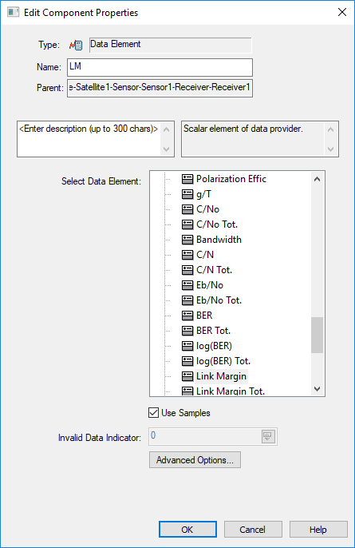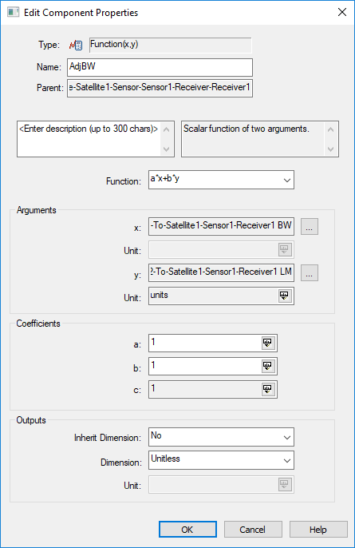

- Adjusted Bandwidth (dB-Hz) – output of dual variable function that computes Bandwidth (dB-Hz) adjusted by Link Margin factor (dB).
- Adjusted Bandwidth (kHz) – output of function that converts from dB-Hz to kHz.

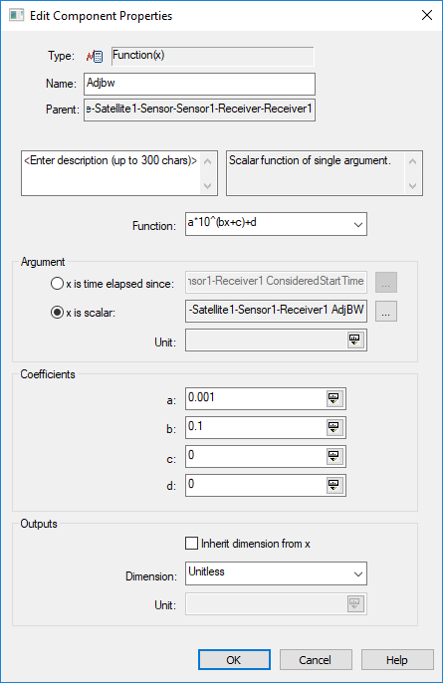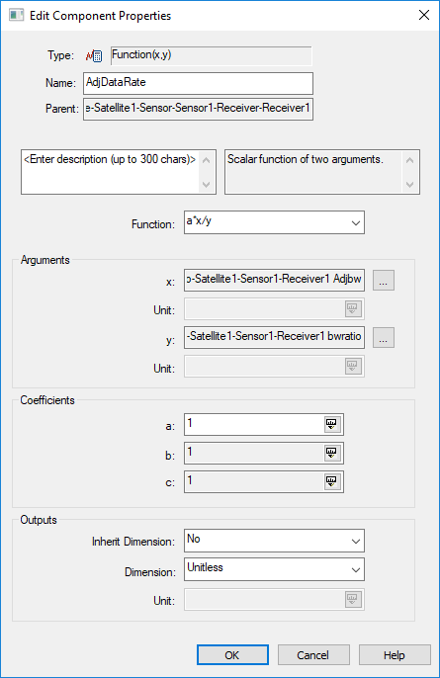

- Bandwidth Ratio – constant value dependent on modulation type. See http://help.agi.com/stk/Content/comm/CommRadar04-05.htm#ModStrd
- Adjusted Data Rate – output of function that computes the Data Rate by applying the Bandwidth Ratio to the Adjusted Bandwidth.

